[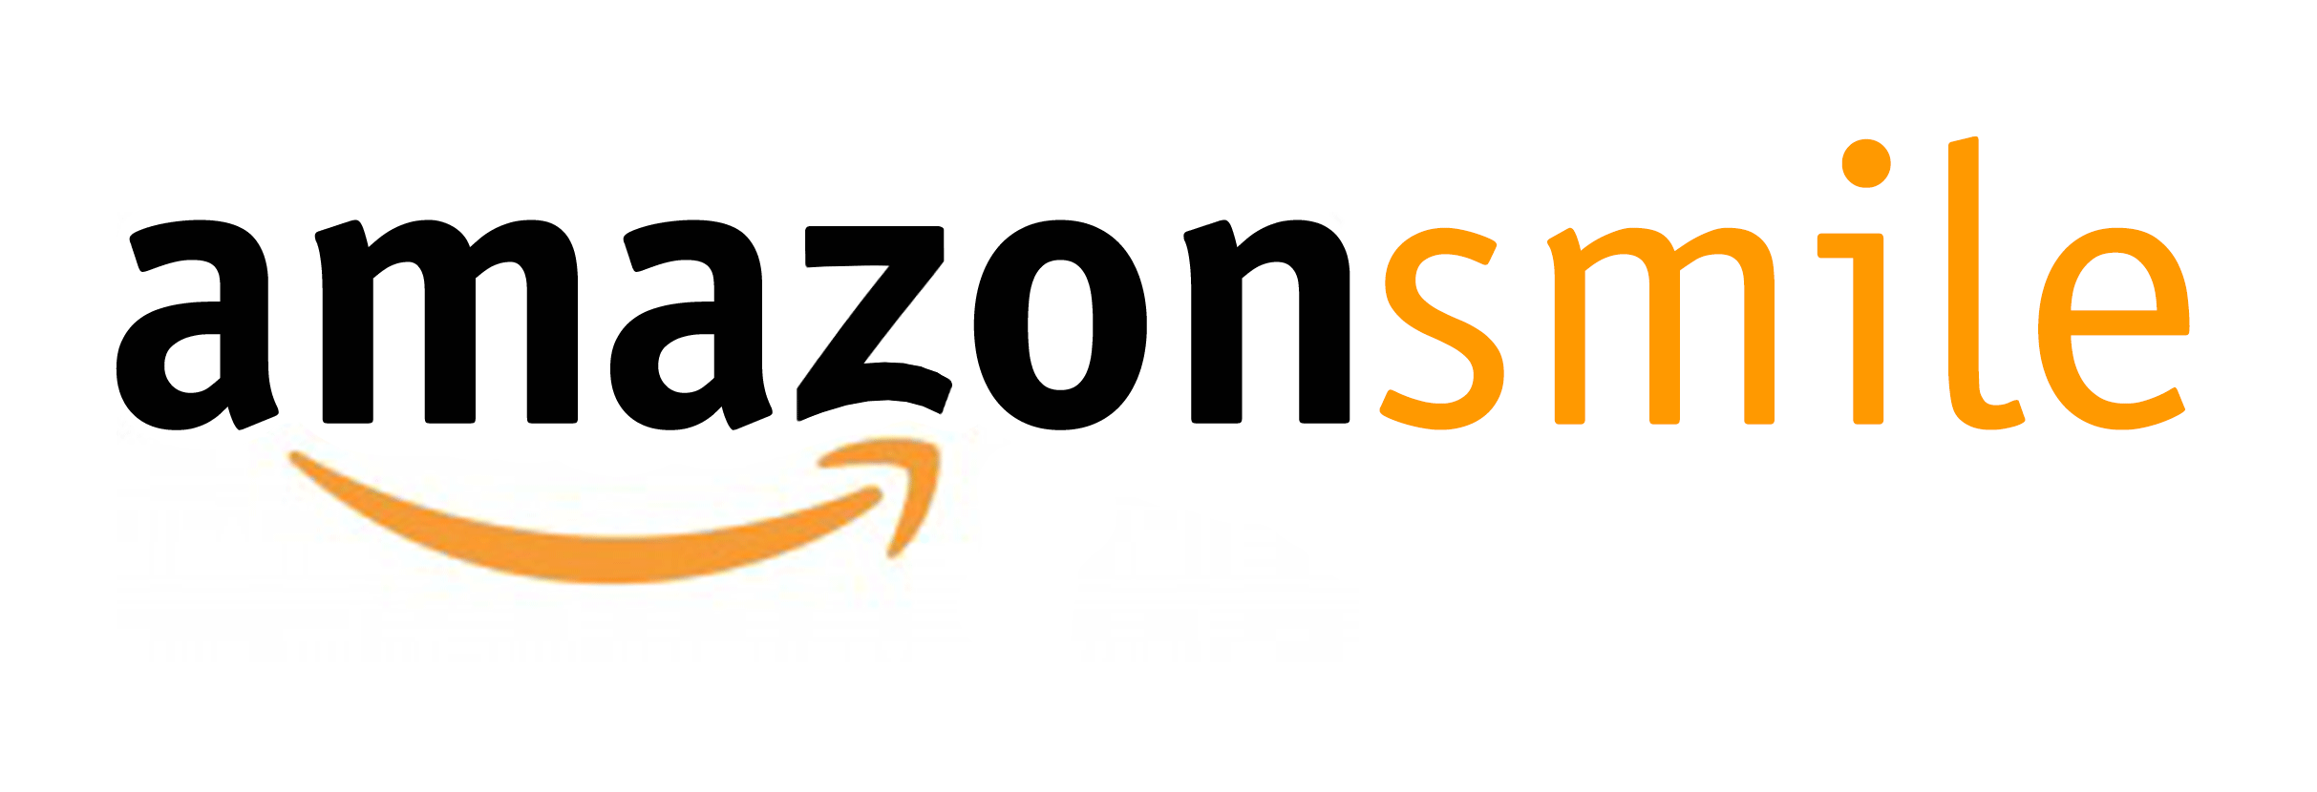](http://www.google.com/url?sa=i&rct=j&q=&esrc=s&source=images&cd=&cad=rja&uact=8&docid=YVLBoHetFyHBfM&tbnid=ob8r_-GaKKhCcM:&ved=0CAUQjRw&url=http://www.linguisticsociety.org/news/2014/07/11/support-lsa-amazonsmile&ei=vKHOU52ZIoakyASp7IHYCQ&bvm=bv.71198958,d.aWw&psig=AFQjCNGI3h9enWPPgkiTQzxlZKAp84cw6A&ust=1406137134833093) You shop. Amazon gives.

* Amazon donates 0.5% of the price of your eligible AmazonSmile purchases to the charitable organization of your choice.
* AmazonSmile is the same Amazon you know. Same products, same prices, same service.
* Support your charitable organization by starting your shopping at **smile.amazon.com**

AmazonSmile is a website operated by Amazon that lets you enjoy the same wide selection of products, low prices, and convenient shopping features as on Amazon.com. The difference is that when you shop on AmazonSmile (smile.amazon.com), the AmazonSmile Foundation will donate 0.5% of the purchase price to the eligible charitable organization of your choice.

**YOU CAN HELP**

**KENT FOOD BANK EARN DONATIONS**

*Just by shopping with your Fred Meyer Rewards Card!*

Sign up for the Community Rewards program by linking your Fred Meyer Rewards Card to Kent Food Bank at:

[www.fredmeyer.com/communityrewards](http://www.fredmeyer.com/communityrewards)

You can search for us by name,

Kent Food Bank or by our NPO # 83698

Every time you shop and use your Rewards Card, you are helping Kent Food Bank earn a donation!

***You still earn your Rewards Points, Fuel Points, and Rebates, just as you do today.***

For more information, please visit [www.fredmeyer.com/communityrewards](http://www.fredmeyer.com/communityrewards)

